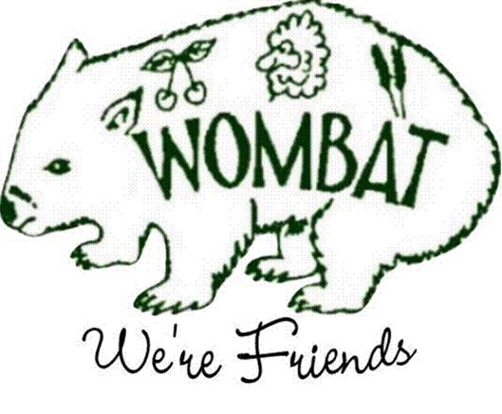
WOMBAT PUBLIC SCHOOL
Principal: Mrs Renae Fairey
School Administration: Mrs Vanessa Layton

Newsletter
2/09/19 2019 Term 3

INFANTS STAR OF THE WEEK

Persaeus Bloor

For

A creative and well presented Information Report.

PRIMARY STAR OF THE WEEK

Rohan Fairey

For

Persistence through pain!

DISTRICT ATHLETICS: Congratulations to Ben, Kelarni, Norah and Cole on their running efforts at Riverina Regional Athletics!

DEBATING COMPETITION DAY: Primary are off to Murringo on Wednesday for their debating competition day. They have been working hard in class to prepare for their debates. They are in two teams arguing the affirmative for ‘School playground equipment should be banned’ and ‘school sports shouldn’t keep score’. This has been quite a challenge as we have many students who feel strongly in the negative!

Please fill out and return the attached Meal order and money tomorrow, Tuesday 3rd September. It would be appreciated if you could reply by Monday evening on our facebook post so that numbers can be submitted to Murringo. Notes are due and must be returned prior to the excursion.

SCHOOL LUNCHES: Karyn is planning to provide Wombat wraps for school lunches this week. Please return orders by Tuesday afternoon! Thank you for supporting our P&C in their fundraising endeavours!

BOOK CLUB: Book Club magazines have been included with this week’s newsletter. If you would like to place an order please return order forms with full payment by Tuesday 10th September.

PHILLIP SHIELD: The annual Phillip Shield will be on Thursday 12th September at Gus Smith Oval. Please complete the permission slip and return to school by Friday 30th August. An alternate date has been set for Tuesday 17th September in the event of bad weather.

MINI KINDIES: We will continue to run the mini kindy days on Thursdays through Week 10 of this term and part of term 4. The first four visits will be for the morning session followed by full day visits for the rest of the program. Photographs of the day were posted to our Wombat Facebook page. Please note there will be No Mini Kindies on the 12th September due to the Phillips Shield Sports Carnival.

PRIMARY EXCURSION: We are pleased to announce that the final costings for the upcoming Broken Bay excursion are set at $530 per student. This covers coach travel on Wilkinson’s, the return ferry ride, all food, 4 nights’ accommodation and the planned activities at Broken Bay. Parents are required to fill in an online Medical and Consent form for each child that is attending the Broken Bay excursion, however, Vanessa has offered to enter these online. Medical and Consent forms must be done by the 14th October 2019 A medical consent template was sent out earlier in the year and we have received many back, additional copies are available in the office

 | MONDAY | TUESDAY | WEDNESDAY | THURSDAY | FRIDAY
Week 7 – TERM 3 | Infants: Renae  Primary: Hamish | Infants: Steph  Primary: Hamish | Infants: Steph  Primary: Hamish  Office: Vanessa | Infants: Renae  Primary: Hamish  Office: Vanessa | Infants: Steph  Primary: Hamish
 |  | Lunch Orders Due  TSS Curriculum Day  English Syllabus training day | Debating @ Murringo  (Primary Students) | School lunches  Mini-K  9 - 11:30
 | 2 | 3 | 4 | 5 | 6
Week 8 - Term 3 | Infants: Renae  Primary: Hamish | Infants: Renae  Primary: Hamish | Infants: Renae  Primary: Hamish  Office: Vanessa | Infants: Renae  Primary: Hamish  Office: Vanessa | Infants: Steph  Primary: Hamish  Office: Vanessa
 | YSS Principal Meeting @ 4pm | Book Club Orders Due. |  | Phillip Shield  No Mini Kindies | Carolynne Director’s Visit
 | 9 | 10 | 11 | 12 | 13
Week 9 – TERM 3 | Infants: Renae  Primary: Hamish | Infants: Steph  Primary: Hamish | Infants: Renae  Primary: Hamish  Office: Vanessa | Infants: Renae  Primary: Hamish  Office: Vanessa | Infants: Steph  Primary: Hamish  Office: Vanessa
 |  | Lunch Orders Due |  | School lunches  Mini-K  9 – 3pm | WH&S  Information Day
 | 16 | 17 | 18 | 19 | 20
Work Health and Safety

A safe school environment is important to our school, please report any safety concerns to the school so we can attend to them appropriately.

